
Hitec University of Taxila

Submitted By:
Ali Raza Khan
23-se-110
Submitted By:
Laiba Shahzad

Visual Programming:

Lab Report 4:

Lab task:

Task 1:
using System;
using System.Drawing;
using System.Windows.Forms;

namespace AttendanceSystem
{
public class AttendanceForm : Form
{
// ── Controls ──────────────────────────────────────────────
private Label lblTitle;
private Label lblSemesterText;
private ComboBox cmbSemester;
private Label lblColName;
private Label lblColDate;
private Label lblColPresent;
private Button btnSubmit;

// Per-student controls (built dynamically)
private string[] studentNames = { "Sadaf", "Faiza", "Tania", "Ahmed", "Sara" };
private Label[] nameLabels;
private Label[] dateLabels;
private CheckBox[] presentBoxes;

// ── Constructor ───────────────────────────────────────────
public AttendanceForm()
{
BuildUI();
}

// ── UI construction ───────────────────────────────────────
private void BuildUI()
{
/* Form */
Text = "Attendance for Final Examination";
Size = new Size(720, 540);
MinimumSize = new Size(720, 400);
StartPosition = FormStartPosition.CenterScreen;
BackColor = Color.White;
Font = new Font("Segoe UI", 9f);

/* Title */
lblTitle = MakeLabel("Attendance for Final Examination",
20, 15, 500, 30,
new Font("Segoe UI", 13f, FontStyle.Bold),
Color.FromArgb(30, 100, 160));

AddSeparator(20, 52, 660);

/* Semester row */
lblSemesterText = MakeLabel("Semester:", 20, 68, 80, 25);

cmbSemester = new ComboBox
{
Location = new Point(105, 66),
Size = new Size(220, 25),
DropDownStyle = ComboBoxStyle.DropDownList
};
cmbSemester.Items.AddRange(new object[] {
"Semester 1","Semester 2","Semester 3","Semester 4",
"Semester 5","Semester 6","Semester 7","Semester 8"
});
cmbSemester.SelectedIndex = 7; // default: Semester 8

AddSeparator(20, 105, 660);

/* Column headers */
lblColName = MakeLabel("Student Name", 20, 112, 200, 25,
new Font("Segoe UI", 9f, FontStyle.Bold));
lblColDate = MakeLabel("Date", 260, 112, 250, 25,
new Font("Segoe UI", 9f, FontStyle.Bold));
lblColPresent = MakeLabel("Present", 590, 112, 80, 25,
new Font("Segoe UI", 9f, FontStyle.Bold));

AddSeparator(20, 140, 660);

/* Student rows */
int n = studentNames.Length;
nameLabels = new Label[n];
dateLabels = new Label[n];
presentBoxes = new CheckBox[n];
string now = DateTime.Now.ToString("dd-MMM-yy h:mm:ss tt");

for (int i = 0; i < n; i++)
{
int y = 148 + i * 38;

nameLabels[i] = MakeLabel(studentNames[i], 20, y + 5, 200, 25);

dateLabels[i] = MakeLabel(now, 260, y + 5, 280, 25,
color: Color.FromArgb(80, 80, 80));

presentBoxes[i] = new CheckBox
{
Location = new Point(600, y + 5),
Size = new Size(20, 20),
Checked = true
};

Controls.Add(nameLabels[i]);
Controls.Add(dateLabels[i]);
Controls.Add(presentBoxes[i]);

if (i < n - 1)
AddSeparator(20, y + 35, 660, Color.FromArgb(230, 235, 240));
}

/* Submit button */
int btnY = 148 + n * 38 + 12;
btnSubmit = new Button
{
Text = "Submit",
Size = new Size(90, 32),
Location = new Point(590, btnY),
BackColor = Color.FromArgb(52, 120, 180),
ForeColor = Color.White,
FlatStyle = FlatStyle.Flat,
Cursor = Cursors.Hand
};
btnSubmit.FlatAppearance.BorderSize = 0;
btnSubmit.Click += OnSubmit;

/* Add controls to form */
Controls.AddRange(new Control[] {
lblTitle, lblSemesterText, cmbSemester,
lblColName, lblColDate, lblColPresent,
btnSubmit
});

Height = btnY + 80;
}

// ── Submit handler ────────────────────────────────────────
private void OnSubmit(object sender, EventArgs e)
{
string msg = $"Attendance recorded for {cmbSemester.SelectedItem}\n\n"
+ "Student\t\tStatus\n"
+ new string('─', 30) + "\n";

for (int i = 0; i < studentNames.Length; i++)
msg += $"{studentNames[i],-16}{(presentBoxes[i].Checked ? "Present" : "Absent")}\n";

MessageBox.Show(msg, "Attendance Summary",
MessageBoxButtons.OK, MessageBoxIcon.Information);
}

// ── Helpers ───────────────────────────────────────────────
private Label MakeLabel(string text, int x, int y, int w, int h,
Font font = null, Color? color = null)
{
var lbl = new Label
{
Text = text,
Location = new Point(x, y),
Size = new Size(w, h),
Font = font ?? this.Font,
ForeColor = color ?? Color.Black
};
return lbl;
}

private void AddSeparator(int x, int y, int w,
Color? color = null)
{
var p = new Panel
{
BackColor = color ?? Color.FromArgb(200, 215, 230),
Location = new Point(x, y),
Size = new Size(w, 1)
};
Controls.Add(p);
}
}

// ── Program entry point ───────────────────────────────────────
static class Program
{
[STAThread]
static void Main()
{
Application.EnableVisualStyles();
Application.SetCompatibleTextRenderingDefault(false);
Application.Run(new AttendanceForm());
}
}
}
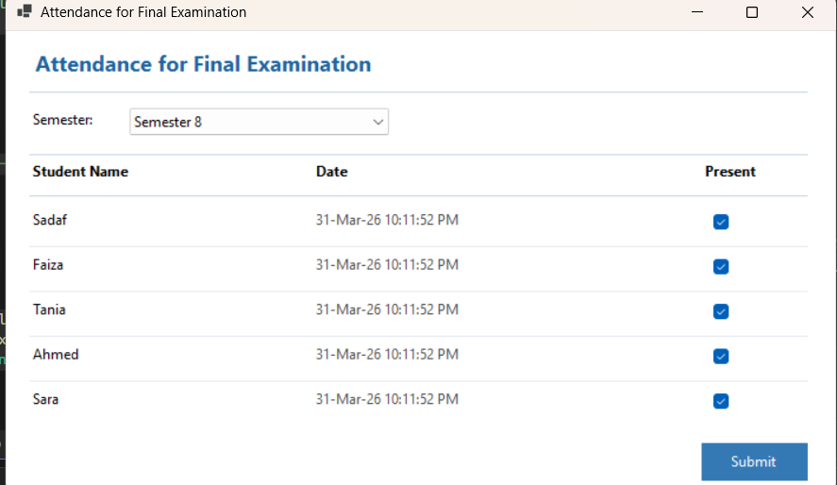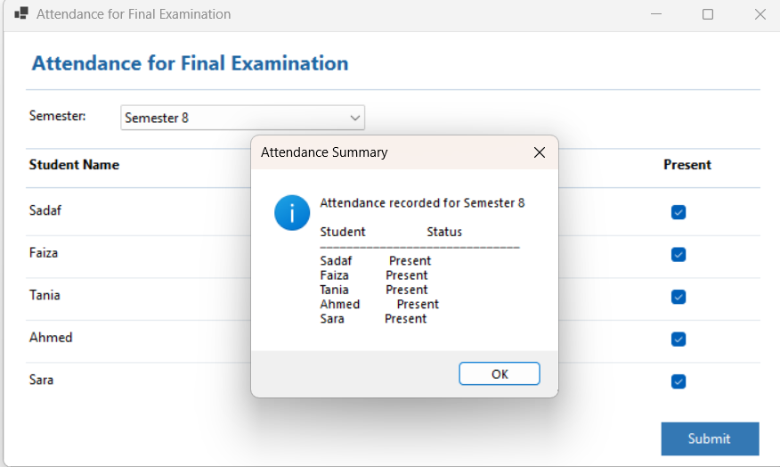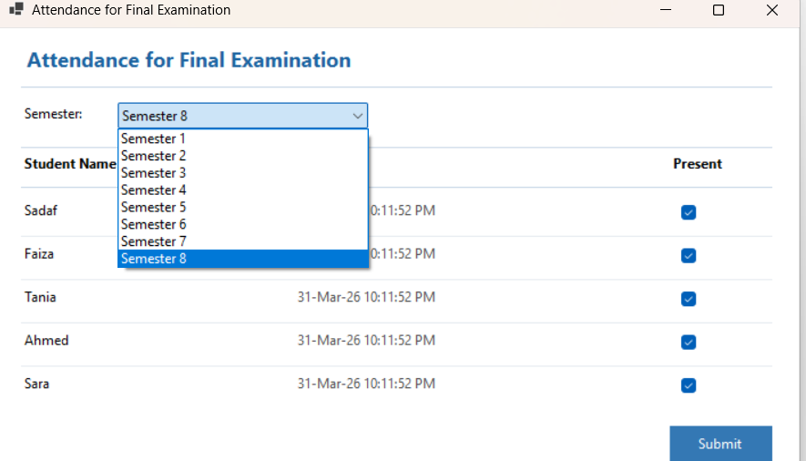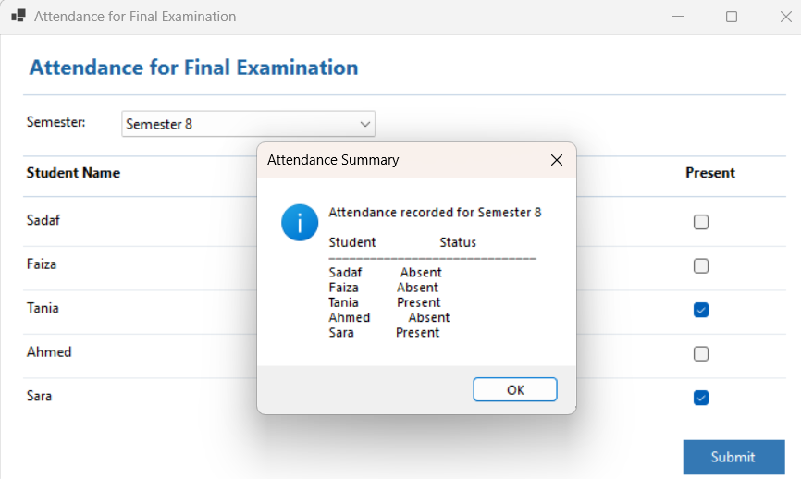

Task 2:
using System;
using System.Drawing;
using System.Windows.Forms;

namespace AttendanceSystem
{
public class AttendanceForm : Form
{
// ── Controls ──────────────────────────────────────────────
private Label lblTitle;
private Label lblSemesterText;
private ComboBox cmbSemester;
private Label lblColName;
private Label lblColDate;
private Label lblColPresent;
private Button btnSubmit;

// Per-student controls (built dynamically)
private string[] studentNames = { "Sadaf", "Faiza", "Tania", "Ahmed", "Sara" };
private Label[] nameLabels;
private Label[] dateLabels;
private CheckBox[] presentBoxes;

// ── Constructor ───────────────────────────────────────────
public AttendanceForm()
{
BuildUI();
}

// ── UI construction ───────────────────────────────────────
private void BuildUI()
{
/* Form */
Text = "Attendance for Final Examination";
Size = new Size(720, 540);
MinimumSize = new Size(720, 400);
StartPosition = FormStartPosition.CenterScreen;
BackColor = Color.White;
Font = new Font("Segoe UI", 9f);

/* Title */
lblTitle = MakeLabel("Attendance for Final Examination",
20, 15, 500, 30,
new Font("Segoe UI", 13f, FontStyle.Bold),
Color.FromArgb(30, 100, 160));

AddSeparator(20, 52, 660);

/* Semester row */
lblSemesterText = MakeLabel("Semester:", 20, 68, 80, 25);

cmbSemester = new ComboBox
{
Location = new Point(105, 66),
Size = new Size(220, 25),
DropDownStyle = ComboBoxStyle.DropDownList
};
cmbSemester.Items.AddRange(new object[] {
"Semester 1","Semester 2","Semester 3","Semester 4",
"Semester 5","Semester 6","Semester 7","Semester 8"
});
cmbSemester.SelectedIndex = 7; // default: Semester 8

AddSeparator(20, 105, 660);

/* Column headers */
lblColName = MakeLabel("Student Name", 20, 112, 200, 25,
new Font("Segoe UI", 9f, FontStyle.Bold));
lblColDate = MakeLabel("Date", 260, 112, 250, 25,
new Font("Segoe UI", 9f, FontStyle.Bold));
lblColPresent = MakeLabel("Present", 590, 112, 80, 25,
new Font("Segoe UI", 9f, FontStyle.Bold));

AddSeparator(20, 140, 660);

/* Student rows */
int n = studentNames.Length;
nameLabels = new Label[n];
dateLabels = new Label[n];
presentBoxes = new CheckBox[n];
string now = DateTime.Now.ToString("dd-MMM-yy h:mm:ss tt");

for (int i = 0; i < n; i++)
{
int y = 148 + i * 38;

nameLabels[i] = MakeLabel(studentNames[i], 20, y + 5, 200, 25);

dateLabels[i] = MakeLabel(now, 260, y + 5, 280, 25,
color: Color.FromArgb(80, 80, 80));

presentBoxes[i] = new CheckBox
{
Location = new Point(600, y + 5),
Size = new Size(20, 20),
Checked = true
};

Controls.Add(nameLabels[i]);
Controls.Add(dateLabels[i]);
Controls.Add(presentBoxes[i]);

if (i < n - 1)
AddSeparator(20, y + 35, 660, Color.FromArgb(230, 235, 240));
}

/* Submit button */
int btnY = 148 + n * 38 + 12;
btnSubmit = new Button
{
Text = "Submit",
Size = new Size(90, 32),
Location = new Point(590, btnY),
BackColor = Color.FromArgb(52, 120, 180),
ForeColor = Color.White,
FlatStyle = FlatStyle.Flat,
Cursor = Cursors.Hand
};
btnSubmit.FlatAppearance.BorderSize = 0;
btnSubmit.Click += OnSubmit;

/* Add controls to form */
Controls.AddRange(new Control[] {
lblTitle, lblSemesterText, cmbSemester,
lblColName, lblColDate, lblColPresent,
btnSubmit
});

Height = btnY + 80;
}

// ── Submit handler ────────────────────────────────────────
private void OnSubmit(object sender, EventArgs e)
{
string msg = $"Attendance recorded for {cmbSemester.SelectedItem}\n\n"
+ "Student\t\tStatus\n"
+ new string('─', 30) + "\n";

for (int i = 0; i < studentNames.Length; i++)
msg += $"{studentNames[i],-16}{(presentBoxes[i].Checked ? "Present" : "Absent")}\n";

MessageBox.Show(msg, "Attendance Summary",
MessageBoxButtons.OK, MessageBoxIcon.Information);
}

// ── Helpers ───────────────────────────────────────────────
private Label MakeLabel(string text, int x, int y, int w, int h,
Font font = null, Color? color = null)
{
var lbl = new Label
{
Text = text,
Location = new Point(x, y),
Size = new Size(w, h),
Font = font ?? this.Font,
ForeColor = color ?? Color.Black
};
return lbl;
}

private void AddSeparator(int x, int y, int w,
Color? color = null)
{
var p = new Panel
{
BackColor = color ?? Color.FromArgb(200, 215, 230),
Location = new Point(x, y),
Size = new Size(w, 1)
};
Controls.Add(p);
}
}

// ── Program entry point ───────────────────────────────────────
static class Program
{
[STAThread]
static void Main()
{
Application.EnableVisualStyles();
Application.SetCompatibleTextRenderingDefault(false);

// Show login form first
using (LoginForm loginForm = new LoginForm())
{
if (loginForm.ShowDialog() == DialogResult.OK)
{
// If login successful, show attendance form
Application.Run(new AttendanceForm());
}
}
}
}
}

